From Royal Albert Hall to Lion Green
Excelsis Chamber Choir ends musical season on a high note

For more information, contact:
Godfrey Bruce-Radcliffe, Chair: chairman@excelsis-choir.co.uk
Christine Asbridge, Publicity: christine@excelsis-choir.co.uk

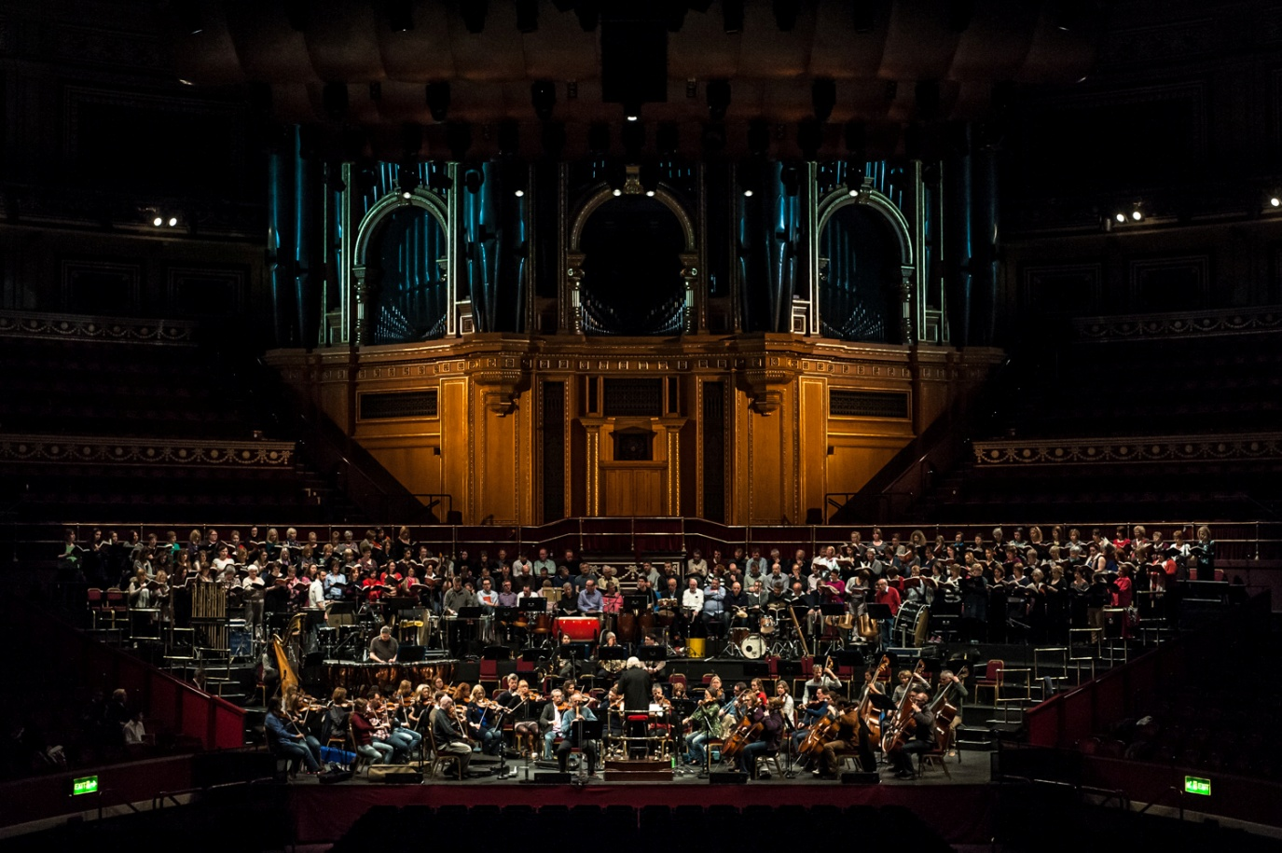
Fresh from performing at Royal Albert Hall on 28 April, Grayshott’s chamber choir, Excelsis, will take part in Haslemere’s Proms on Saturday, 11 May, at 7.45 p.m.

The prestigious chamber choir travelled to London to perform Karl Jenkins’ Requiem and The Armed Man, under the baton of the composer himself. Excelsis joined forces with Côr Caerdydd and the Camerata Chamber Choir, as well as the Royal Philharmonic Concert Orchestra, performing to a sell-out crowd exceeding 4,000.

‘Being invited to perform at Royal Albert Hall was a milestone for Excelsis. Everyone in the choir worked hard to prepare for the concert, and the experience far exceeded our expectations,’ said Excelsis Director of Music Robert Lewis. ‘Excelsis keeps going from strength to strength – and we are looking forward to working with Karl Jenkins again in the future.’

Excelsis has built a strong reputation with Jenkins, CBE, working with him in 2009 for the first amateur performance in Europe of his Stabat Mater, and most recently in September 2012, when he conducted the choir in The Peacemakers in Grayshott.

Excelsis will be part of a 100-member festival choir the night of the Haslemere Proms, performing popular works including Handel’s Hallelujah Chorus and Zadok the Priest.

Photographs courtesy of Edward Radcliffe from www.wemakepictures.co.uk and Peter Sillick.

